Swinburne University of Technology

**Interface Design and Development**

Project Overview: Trinacria Ristorante Website

Marco Giacoppo (104071453)

Tuesday 10:30

2024 Semester

# Introduction

Trinacria Ristorante is an innovative web application designed to offer a seamless blend of Italian and Balinese culinary experiences to its users. The website combines the authentic tastes of Italian cuisine with unique Balinese flavors, presented in an easily navigable and visually appealing digital format. The primary goal of the website is to allow users to explore the menu, make online reservations, order food, and learn more about the unique culinary fusion that Trinacria offers.

# Key Features

* **Responsive Navigation Bar**: Includes links to different sections of the website such as Home, About, Promotions, Menu, and Table reservation. It transforms into a hamburger menu on smaller screens for better mobile accessibility.
* **User Account Management**: Supports user functionalities such as login, registration, and account management directly from the navbar. Logged-in users can access personalized features like order history.
* **Dynamic Content Display**: Features sections like Home Main, where users are greeted with vibrant images and enticing descriptions of the cuisine, and Home About, which details what makes Trinacria special.
* **Menu Exploration**: Categorized display of food items like Pasta, Pizza, Seafood, and more, with each category easily accessible through visually appealing boxes that expand into detailed menus on click.

# Design and Layout

The website employs a clean, modern design with a focus on high-quality images and a cohesive color scheme that reflects the richness of Italian and Balinese cuisines. The layout is designed to be responsive, ensuring a consistent and accessible user experience across all device types and screen sizes.

# Screenshots

The Home Page, showing the main navigation bar and the introductory content section.

The Menu Section, displaying the categorized food items.

The About Page, detailing the fusion of Italian and Balinese culinary practices.

The User Account Login or Registration Page.

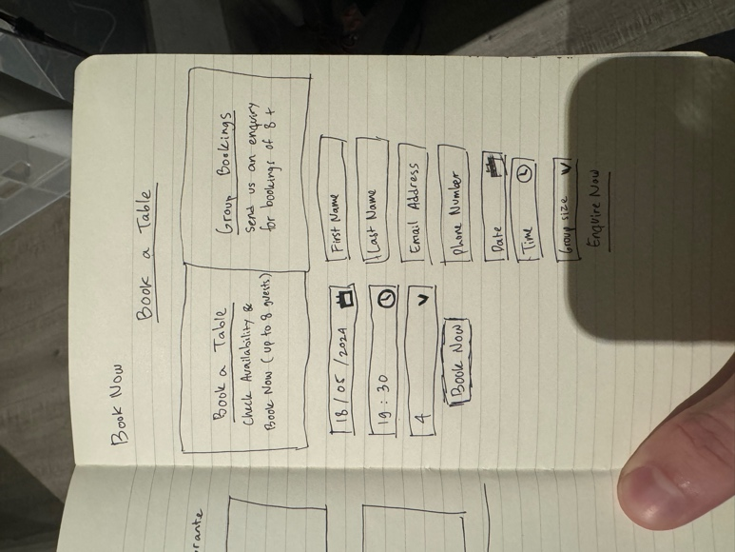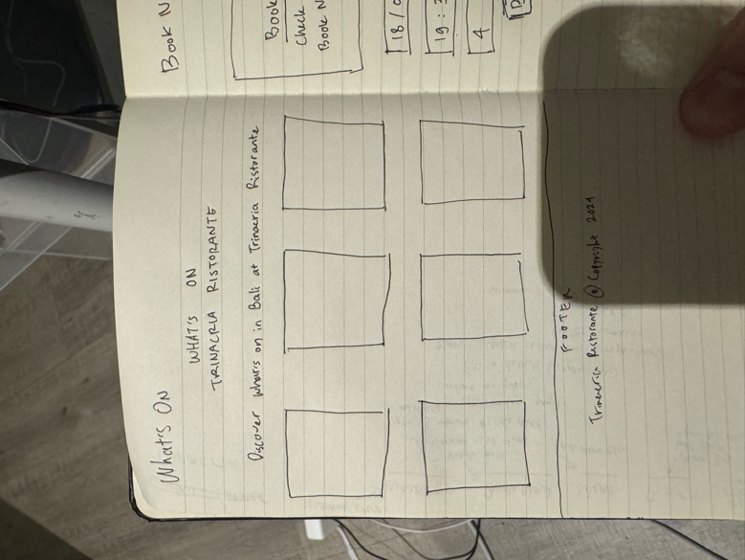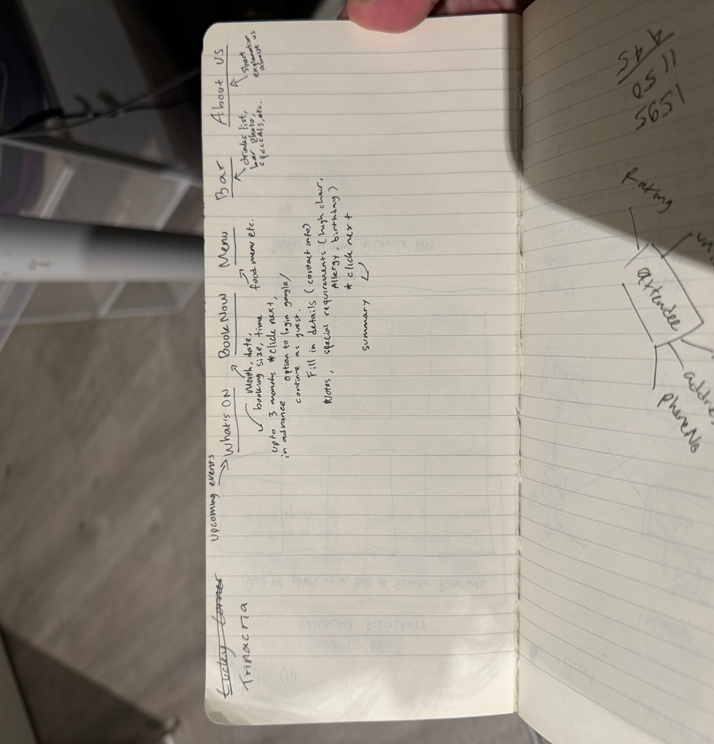

Figure 1: Initial Sketches

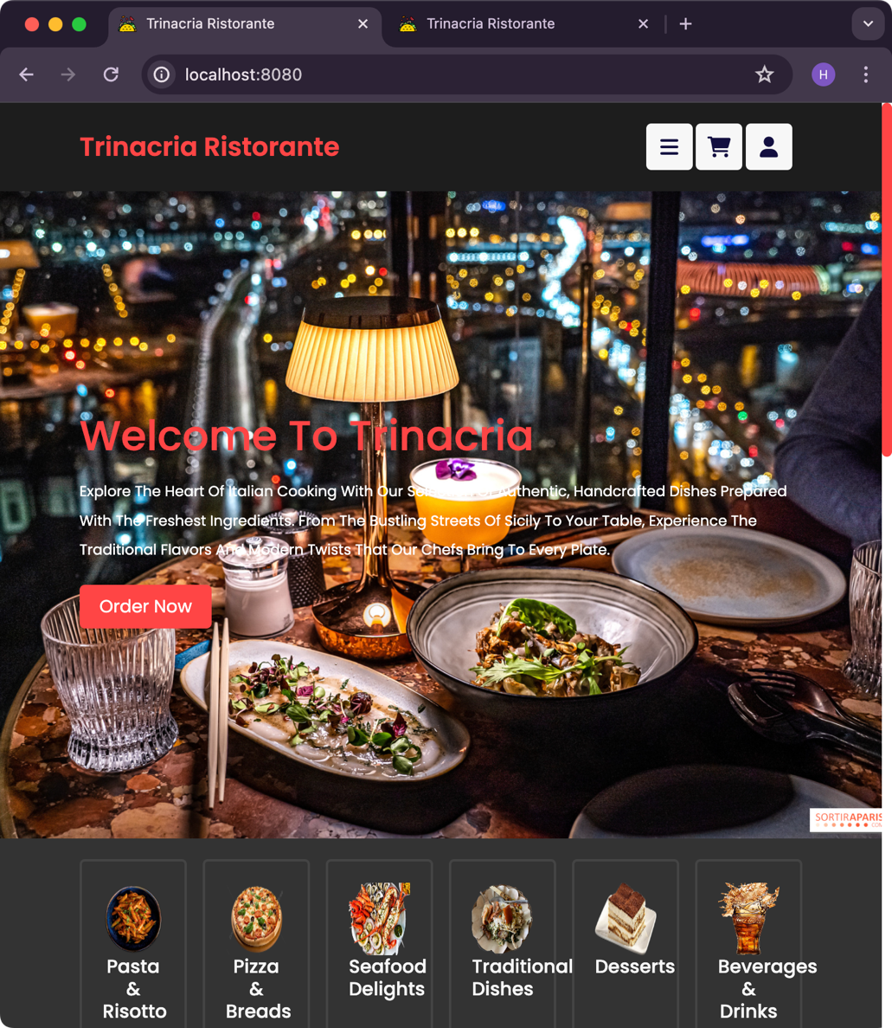

Figure 2: Home page design

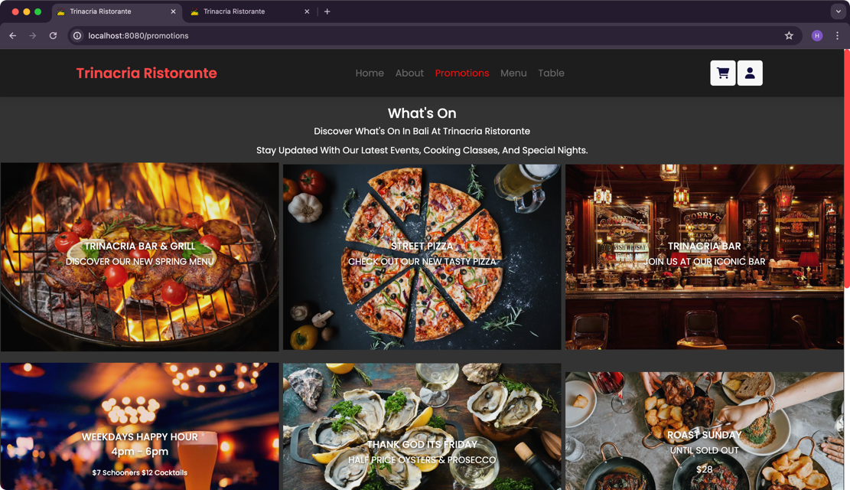

Figure 3: Promotion page design

Figure 4: Login function for users

# Technologies Used

* **Frontend**: Vue.js for dynamic content handling and responsive design.
* **Styling**: Bootstrap for layout and responsiveness, ensuring the website is mobile-friendly and accessible.

# Conclusion

Trinacria Ristorante aims to bridge the gap between traditional dining and the digital experience, offering users a platform not just to order food but to explore a unique culinary heritage. Future enhancements will focus on integrating more interactive features, such as real-time table booking and user reviews.